PRODUCT BUNDLE ANALYSIS IN R

**A MINI PROJECT REPORT**

Submitted in partial fulfilment of

BACHELOR OF TECHNOLOGY

IN

ARTIFICIAL INTELLIGENCE AND DATA SCIENCE

By

Mr. N. Jagadeesh 21BQ1A5436

Mr. CH. Raghavendra 21BQ1A5408

Mr. V. Raghavendra 21BQ1A5455

Mr. V. Aakash 21BQ1A5457

UNDER THE GUIDENCE OF

K. RAJINI, M. Tech, (Ph. D), ASSOC PROF

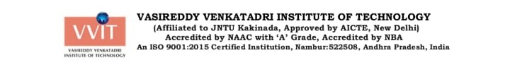

**DECLARATION**

I hereby declare that this project report titled **PRODUCT BUNDLE IDENTIFICATION USING** **R** done by **N. JAGADEESH**. I affirm that this report has been completed as a Mini Project in R Programming in **Vasireddy** **Venkatadri Institute of Technology**. I further declare that the information presented in this report is authentic, and any external sources used for reference have been duly acknowledged through appropriate citations and references. The ideas, concepts, and conclusions presented herein are the product of my own research and analysis.

**Signature by Candidate**

**(N. JAGADEESH)**

**CERTIFICATE**

This is to certify that the project entitled **PRODUCT BUNDLE IDENTIFICATION USING R** is the bona fide work carried out by **Mr. N. JAGADEESH (21BQ1A5436)** in partial fulfilment of the requirements for the award of the degree Bachelor of Technology in Artificial Intelligence and Data Science from **Vasireddy Venkatadri Institute Of** **Technology** during the year 2022-23 under supervision and guidance of (Mrs. K. Rajani).

Signature by Guide Signature by H.O.D

(K. Rajani) (T. Sudhir)

**ACKNOWLEDGEMENTS**

It is our pleasure to express our deep and sincere gratitude to our mini project guide Mrs. P. Rajani, M. Tech, (Ph. D), Assoc Professor, for extending his sincere and heartfelt guidance throughout this project work.

We greatly indebted to Dr . T. Sudhir, Professor & Head of the Department, for providing motivation and valuable suggestions at every stage of our course of study.

We extend our sincere thanks to all other Teaching and Non-Teaching Faculty members of the department for their cooperation and encouragement throughout our course of study.

We affectionately acknowledge our friends for their motivation and suggestions which helps us in successfully completing our course.

We have no words to acknowledge the warm affection, constant inspiration and encouragement that we received from our Parents and Family Members.

Mr. N. Jagadeesh 21BQ1A5436

Mr. CH. Raghavendra 21BQ1A5408

Mr. V. Raghavendra 21BQ1A5455

Mr. V. Aakash 21BQ1A5457

**PRODUCT BUNDLE IDENTIFICATION USING R**

**ABSTRACT**

This abstract introduces a novel method for identifying product bundles within large datasets. By leveraging advanced data analytics and machine learning techniques, our approach efficiently analyses product attributes, sales patterns, and customer behaviour to accurately identify and categorize product bundles. The proposed system significantly reduces manual effort and improves the accuracy of bundle identification, enabling businesses to optimize pricing strategies, enhance customer experience, and increase revenue.

**Product Bundle Identification using Semi-Supervised Learning**

Information systems

1.World Wide Web

2.Web applications

3.Electronic commerce

4.Online shopping

Theory of computation

1.Theory and algorithms for application domains

2.Machine learning theory

**Pictorial Identification of The Project** 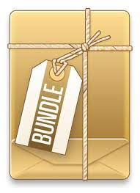:

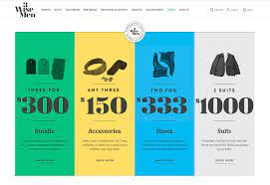

These are some kind of the representation of the project which deals about the bundling the frequent types of the materials required.

**Some More Applications of The Project In Daily Life:**

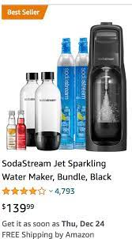

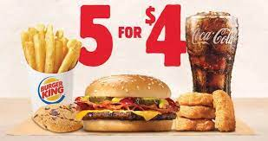

Online shopping also uses the process same as bundling the product criteria.

What is product bundling?

Product bundling is a technique in which several products are grouped together and sold as a single unit for one price. This strategy is used to encourage customers to buy more products. McDonald’s Happy Meals are an example of product bundles. Instead of selling a burger, soda, and french fries separately, they are sold as a combination, which leads to more sales than offering them separately.

## Advantages of product bundling

Bundling helps you do much more with your existing stock. Let’s take a look at the advantages of product bundling and how it can be beneficial for your business.

### 1.Increase your average order value

Product bundling can increase the profits and sales of individual items over time. By grouping your items together you can make your customers buy more than one product during a single purchase, which increases your average order value. For example: Instead of buying just one pencil during a single purchase, your customer can be given an option to buy a pencil, eraser and sharpener as a bundle, making them purchase more than one product thereby increasing your average order value.

### 2.Decreases marketing and distribution costs

Bundling enables you to sell more and decrease marketing and distribution costs. Instead of marketing every product you can group complementary products together and market them as a single product. By packaging different items together you only need one warehouse bin to store them instead of different bins. Also, bundling helps you ship fewer boxes of individual items and saves you money on postage.

### 3.Reduce inventory waste

Merchandise that doesn’t get sold remains in your inventory as dead stock, adding to your holding costs, and is eventually discarded as waste. You can use bundling to clear out this dead stock before it becomes a problem. If you bundle a slow-moving or stagnant item with a faster-selling product, customers will see the bundle as a bargain and be more inclined to buy it. This helps reduce your inventory waste, free up warehouse space, and decrease your inventory holding costs.

## Types and Examples of Product Bundles

There are several different bundling techniques which are used to group products:

1. Pure bundles
2. New product bundles
3. Mix-and-match bundles
4. Cross-sell bundles
5. Gifting bundles
6. Inventory clearance bundles
7. Buy-one-get-one bundles

### 1.Pure bundles

In pure bundling, the individual products that make up the bundle can be purchased only as a bundle and not as standalone products. This technique limits the choices offered to the consumer. For example, HelloFresh is a company which does pure bundling successfully. It bundles the ingredients that their customers need to cook a healthy meal. They offer meal options based on the number of people and recipes the customer requires each week, but they don’t allow you to choose the ingredients as individual items that can be bought separately.

### 2.New product bundling

In this technique, newly-launched products are grouped along with existing or popular products as a promotion to help customers discover your latest product. This method is used by ecommerce stores, which mix new products with their well-known merchandise to gain some exposure for the new product. The more well-received the existing product is in the market, the more it brings the buyer closer to the new product. For example: The Nintendo switch + the legend with Zelda product bundle, is one of the fast-selling Nintendo’s bundle, in this bundle Nintendo introduced their brand new games which is grouped together along with their existing best selling products. This bundle offers an unique Zelda carrying case which is available with this bundle exclusively and two brand new games (Breath of the wild and Super Mario Kart) along with the accessories for gaming.

### 3.Mix-and-match bundles

The mix-and-match bundling technique allows the customer to choose among multiple similar products. This is mostly done by brick-and-mortar stores for fast-moving consumer products such as perishables or bulk items. Here, you specify a few products for your customers to choose from and they can create their own custom bundle from the options available. This method helps the customer feel that they’re in direct control of what they want to buy, thereby increasing the perceived value of the item. It’s the perfect method for encouraging your customers to buy products in bulk without forcing them to buy items which don’t interest them. For example, some retail stores offer a deal where you can match complementary pieces of clothing from an array of choices for a fixed price, such as any shirt along with any pair of trousers for $50.

### 4.Cross-sell bundles

In this bundling technique, retailers sell a complementary product as an add-on to a main product. This type of bundling works well with lower-priced items, or accessories or parts that go with a more expensive item. For example, if you buy an iPhone, you would probably like to buy a case along with it. So the iPhone and case can be sold together as a bundle.

### 5.Gifting bundles

Gift bundles are aimed at shoppers who want to give a bundle of complementary products together to a loved one. This type of bundle is mostly sold during holiday seasons. For example, beauty brand Estee Lauder offers a popular protect-and-hydrate gift set containing four skincare products that work together.

### 6.Inventory clearance bundling

In this bundling technique, you pair a faster-moving item in the inventory with a stagnant or slower-moving item to clear inventory space and decrease your inventory holding costs. This method includes discounts on your bundles so that shoppers who are interested in a top-selling item will see the whole bundle as a bargain and will be more inclined to buy it. For example, the popular specialty tea retailer T-WE found out that their tea accessories were selling faster than their teas (which was unfortunate, because the teas offered a higher profit margin).

### 7.Buy-one-get-one bundles

This bundling is used when you buy one main item, you can avail a discount for another complimentary product or get another product free. This is a best used technique for one time purchase products For example, electronics, if a customer buys a hair dryer they wouldn’t be coming in to buy the same product again. Hence, offering a complimentary product, discount or gift card will encourage your customers to add more items to their carts at a lesser price.

Bundling adds value to your products by adding extra features or products to your existing purchase. You can tailor your product offerings according to the preference of your customers to align with their wants.

**ABOUT APRIORI ALGORITHM:**

Apriori algorithm refers to the algorithm which is used to calculate the association rules between objects. It means how two or more objects are related to one another. In other words, we can say that the apriori algorithm is an association rule leaning that analyses that people who bought product A also bought product B.

The primary objective of the apriori algorithm is to create the association rule between different objects. The association rule describes how two or more objects are related to one another. Apriori algorithm is also called frequent pattern mining. Generally, you operate the Apriori algorithm on a database that consists of a huge number of transactions. Let's understand the apriori algorithm with the help of an example; suppose you go to Big Bazar and buy different products. It helps the customers buy their products with ease and increases the sales performance of the Big Bazar. In this tutorial, we will discuss the apriori algorithm with examples.

## What is Apriori Algorithm?

Apriori algorithm refers to an algorithm that is used in mining frequent products sets and relevant association rules. Generally, the apriori algorithm operates on a database containing a huge number of transactions. For example, the items customers but at a Big Bazar.

Apriori algorithm helps the customers to buy their products with ease and increases the sales performance of the particular store.

Components of Apriori algorithm

The given three components comprise the apriori algorithm.

1. Support
2. Confidence
3. Lift

Let's take an example to understand this concept.

We have already discussed above; you need a huge database containing a large no of transactions. Suppose you have 4000 customers transactions in a Big Bazar. You have to calculate the Support, Confidence, and Lift for two products, and you may say Biscuits and Chocolate. This is because customers frequently buy these two items together.

Out of 4000 transactions, 400 contain Biscuits, whereas 600 contain Chocolate, and these 600 transactions include a 200 that includes Biscuits and chocolates. Using this data, we will find out the support, confidence, and lift.

### **Support**

Support refers to the default popularity of any product. You find the support as a quotient of the division of the number of transactions comprising that product by the total number of transactions. Hence, we get

Support (Biscuits) = (Transactions relating biscuits) / (Total transactions)

= 400/4000 = 10 percent.

### **Confidence**

Confidence refers to the possibility that the customers bought both biscuits and chocolates together. So, you need to divide the number of transactions that comprise both biscuits and chocolates by the total number of transactions to get the confidence.

Hence,

Confidence = (Transactions relating both biscuits and Chocolate) / (Total transactions involving Biscuits

= 200/400

= 50 percent.

It means that 50 percent of customers who bought biscuits bought chocolates also.

### **Lift**

Consider the above example; lift refers to the increase in the ratio of the sale of chocolates when you sell biscuits. The mathematical equations of lift are given below.

Lift = (Confidence (Biscuits - chocolates)/ (Support (Biscuits)

= 50/10 = 5

It means that the probability of people buying both biscuits and chocolates together is five times more than that of purchasing the biscuits alone. If the lift value is below one, it requires that the people are unlikely to buy both the items together. Larger the value, the better is the combination.

How does the Apriori Algorithm work in Data Mining?

We will understand this algorithm with the help of an example

Consider a Big Bazar scenario where the product set is P = {Rice, Pulse, Oil, Milk, Apple}. The database comprises six transactions where 1 represents the presence of the product and 0 represents the absence of the product.

|  |  |  |  |  |
| --- | --- | --- | --- | --- |
| **Transaction ID** | **Rice** | **Pulse** | **Oil** | **Apple** |
| t1 | 1 | 1 | 1 | 0 |
| t2 | 0 | 1 | 1 | 1 |
| t3 | 0 | 0 | 0 | 1 |
| t4 | 1 | 1 | 0 | 1 |
| t5 | 1 | 1 | 1 | 0 |
| t6 | 1 | 1 | 1 | 1 |

The Apriori Algorithm makes the given assumptions

* All subsets of a frequent itemset must be frequent.
* The subsets of an infrequent item set must be infrequent.
* Fix a threshold support level. In our case, we have fixed it at 50 percent.

**Step 1**

Make a frequency table of all the products that appear in all the transactions. Now, short the frequency table to add only those products with a threshold support level of over 50 percent.

We find the given frequency table.

|  |  |
| --- | --- |
| **Product** | **Frequency (Number of transactions)** |
| Rice (R) | 4 |
| Pulse(P) | 5 |
| Oil(O) | 4 |
| Milk(M) | 4 |

The above table indicated the products frequently bought by the customers.

**Step 2**

Create pairs of products such as RP, RO, RM, PO, PM, OM. You will get the given frequency table.

|  |  |
| --- | --- |
| **Itemset** | **Frequency (Number of transactions)** |
| RP | 4 |
| RO | 3 |
| RM | 2 |
| PO | 4 |
| PM | 3 |
| OM | 2 |

**Step 3**

Implementing the same threshold support of 50 percent and consider the products that are more than 50 percent. In our case, it is more than 3

Thus, we get RP, RO, PO, and PM

**Step 4**

Now, look for a set of three products that the customers buy together. We get the given combination.

1. RP and RO give RPO
2. PO and PM give POM

**Step 5**

Calculate the frequency of the two item sets, and you will get the given frequency table.

|  |  |
| --- | --- |
| **Itemset** | **Frequency (Number of transactions)** |
| RPO | 4 |
| POM | 3 |

If you implement the threshold assumption, you can figure out that the customers' set of three products is RPO.

We have considered an easy example to discuss the apriori algorithm in data mining. In reality, you find thousands of such combinations.

Note: Small Project On Product Bundle Identification Steps To Get The Details Of The Bundle That Too With A Jitter Plot Analysis Of The Data Using Apriori Algorithm.

**Product Bundle Identification Project in R Step By Step:**

To identify product bundles in R, you can use association rule mining algorithms such as Apriori or FP-growth. Here is a step-by-step guide to implementing the Apriori algorithm:

*step 1:*

Load the necessary libraries:

$$

library(arules)

library(arulesViz)

$$

*step 2:*

Import your data into R. This should be in the form of a transaction dataset, where each row represents a unique transaction and each column represents an item in that transaction.

Convert your data into a binary format using the transactions() function:

$$

basket <- read.transactions("yourdata.csv", sep=",")

$$

*step 3:*

Use the apriori() function to run the Apriori algorithm on your data:

$$

rules <- apriori(basket, parameter=list(support=0.005, confidence=0.2, minlen=2))

$$

Here, support is the minimum support threshold (i.e., the minimum percentage of transactions that contain a particular itemset), confidence is the minimum confidence threshold (i.e., the minimum percentage of times the consequent occurs when the antecedent occurs), and minlen is the minimum length of an itemset.

*step 4:*

Use the summary() function to view the results of the Apriori algorithm:

$$

summary(rules)

$$

This will show you the number of rules that were generated, as well as statistics such as support, confidence, and lift for each rule.

*step 5:*

Visualize the rules using the plot() function:

$$

plot(rules)

$$

This will generate a scatterplot of the rules, where each point represents a rule and the x and y axes represent the support and confidence, respectively.

*step 6:*

Optionally, you can filter the rules based on certain criteria using the subset() function:

$$

filtered_rules <- subset(rules, subset = lift > 1.2 & confidence > 0.5)

$$

This will filter the rules based on a minimum lift and confidence threshold.

Overall, the Apriori algorithm is a powerful technique for identifying product bundles in large datasets, and it can be easily implemented in R using the arules and arulesViz packages.

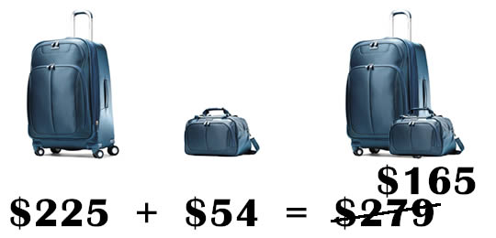

Output For the Above Code using R:

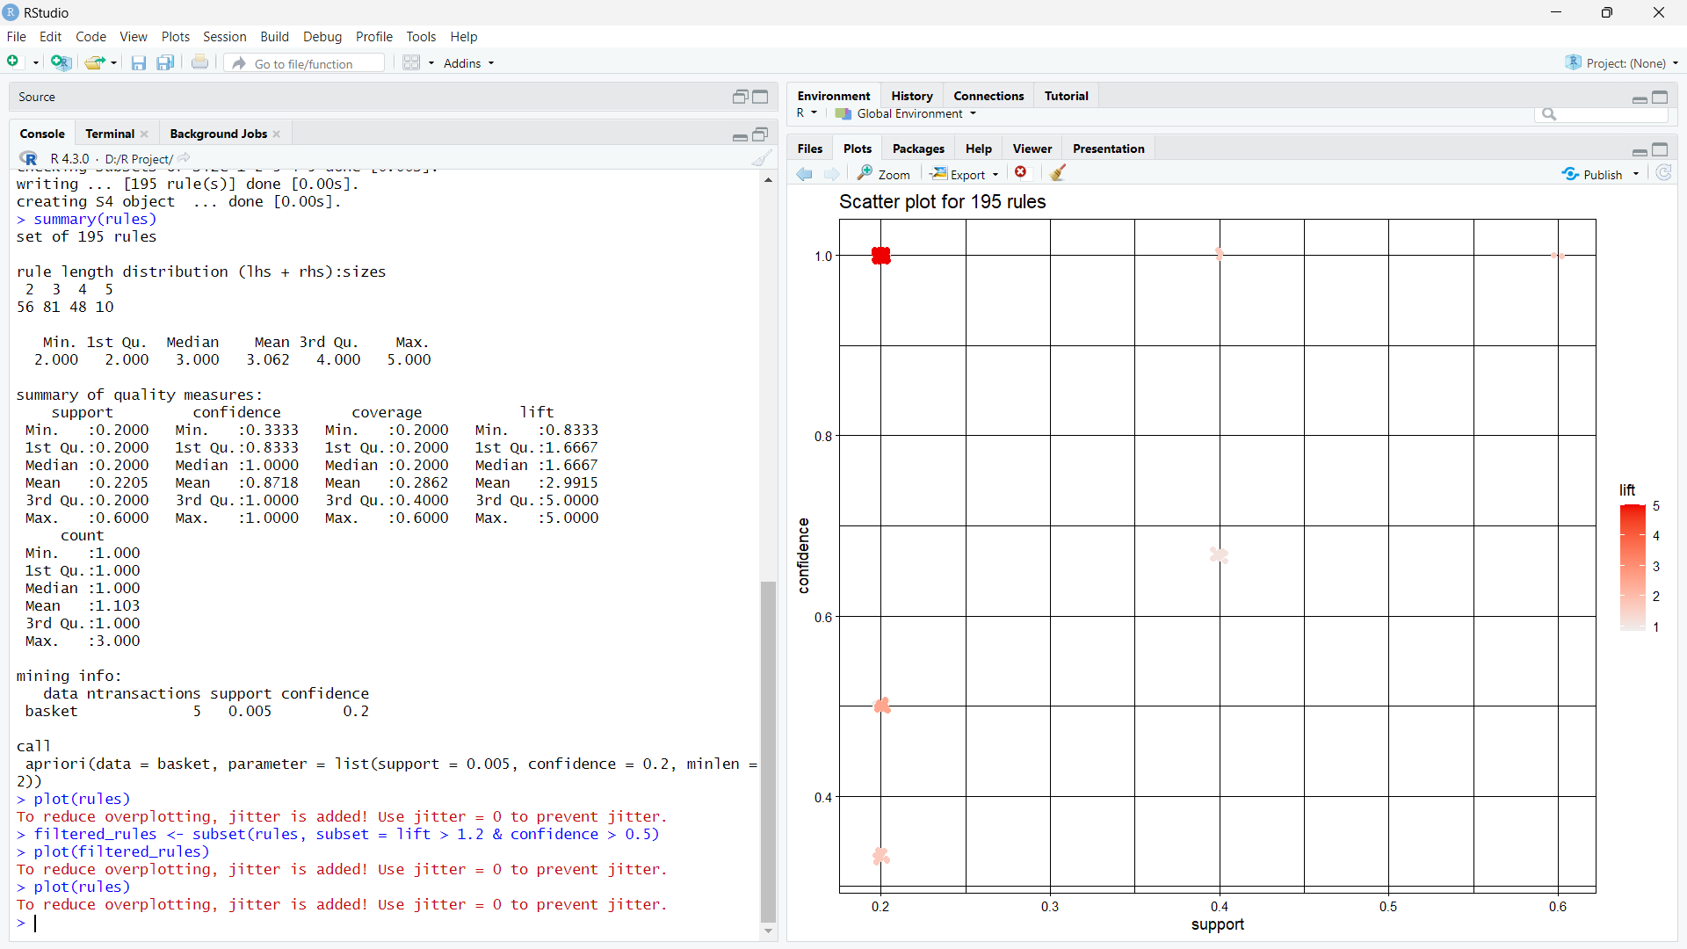



Here The Graph Represents The 195 Rules to Be Followed.

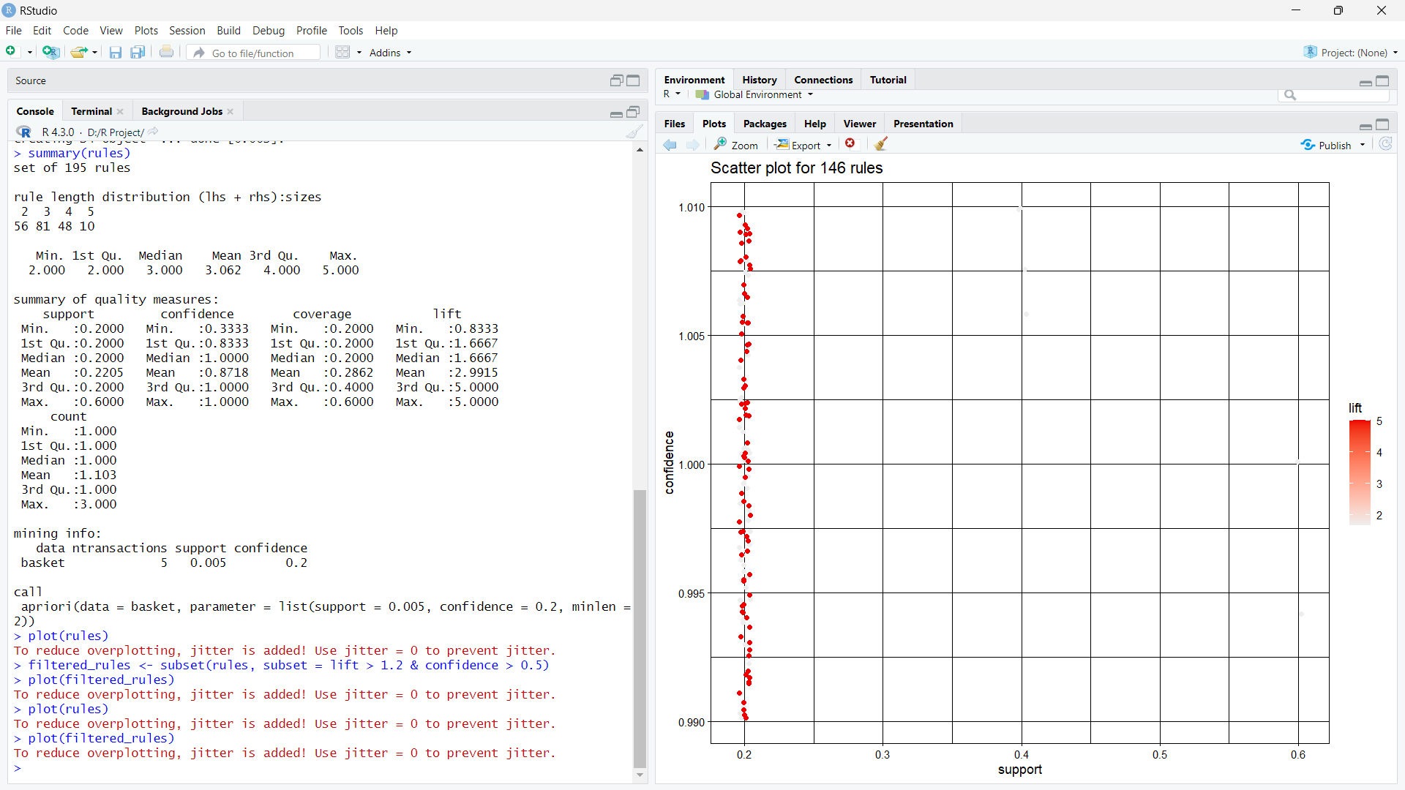

Here The Scatter Plot Represents the Plotting Of filtered_Rules and To Follow The 146 Rules.

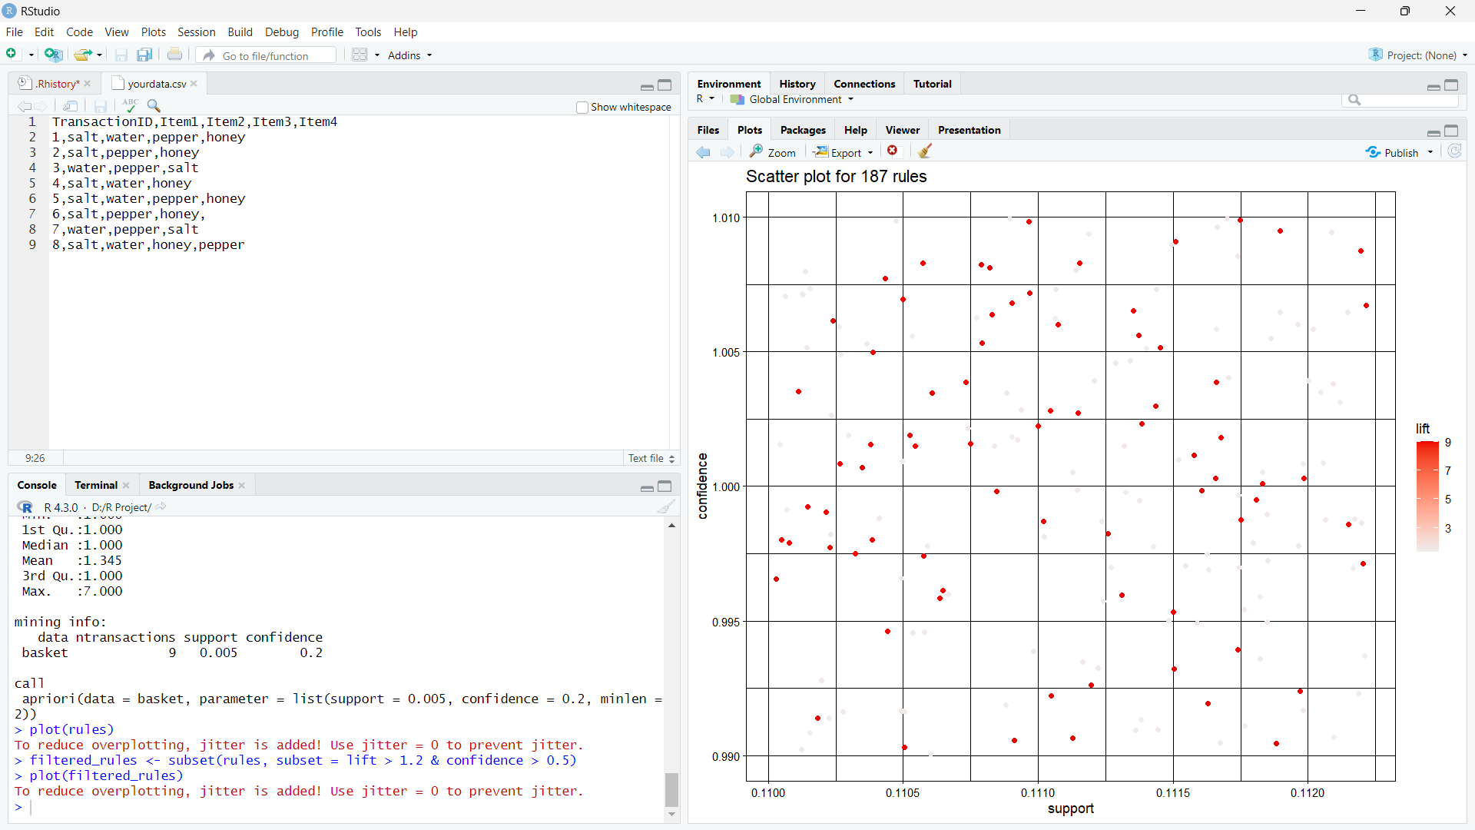

here we can observe that the modification in the data may result in the number of the rules to be followed by the apriori algorithm also.

intensionally we increased some data to the previous data and now, the rules of the apriori algorithm increased to 187 rules according to the data.

APPLICATIONS OF PRODUCT BUNDLE IDENTIFICATION:

1. Mix low selling items with fast-moving ones

2. Show a way out of the ‘multiple choice’ complication

3. Make the most of buy-more-pay-less bundles

4. Reward your customers with a discount

5. Give them a "reason" to buy more

6. Harness the power of personalization

7. Make it easy for them to keep buying from you

8. Get them into the DIY mode

9. Make seasonal shopping more attractive

10. Help customers discover new products

11. Make it cheaper to buy favourite.